THEORIC CONTENTS

* Lesson 2. Algorithms.
* Lesson 3. Data Types.
* Lesson 4. Operators and Expressions.
* Lesson 5. Input and Output
* Lesson 6. Flow Control: Selection
* Lesson 7. Flow Control: Repetition
* Lesson 8. Modular Programming

GITHUB CLASSROOM ASSIGNMENT

https://classroom.github.com/a/5z6_eaDo

PROPOSED EXERCISES

Exercise 1. Design and implement a program in C using modular programing that displays a sequence of primitive integers from an initial value to a final value. The initial and final values must be given by the user. The initial and final values must be greater than 0 and less than 100.

*Exercise 2.* Design and implement a C program using modular programing that solves the next problem definition:

Consider the following table as the list of products that are served at a bar, with their corresponding prices.

|  |  |  |
| --- | --- | --- |
| |  | | --- | | **Sandwich/Roll** | | **Price** |
| Sausage | 1.10 |
| Tuna | 1.40 |
| **Drinks** |  |
| Water | 0.50 |
| Coca Cola | 0.75 |
| Orange Juice | 0.70 |

Write a program that asks the user how much has consumed of each product. Once, all the data have been entered, the program should display the total bill corresponding to the user and should receive how much has paid the user.

Next, the screen should be cleared with system**("cls")** of **stdlib.h** and the following messages should be displayed:

xx sandwiches of sausage at xx.xx euros are xxx.xx euros

xx sandwiches of tuna at xx.xx euros are xxx.xx euros

xx bottles of water at xx.xx euros are xxx.xx euros

xx bottles of coca cola at xx.xx euros are xxx.xx euros

xx glasses of orange juice at xx.xx euros are xxx.xx euros

-----------------------------------------

TOTAL: xxx.xx euros

Payment: xxx.xx euros

Refund: xxx.xx euros

**NOTE:** Prices must be declared as CONSTANTS.

|  |  |
| --- | --- |
|  |  |

*Exercise 3*. Design and implement a C program using modular programing that solves the next problem definition:

A car parts company needs a program that computes and displays the selling price (Euros) of its products. In this sense, the program should apply the following formula:

|  |  |
| --- | --- |
| $$profit=costprice*\frac{margin}{100}$$ $$sellingprice=costprice+profit$$ |  |
|  | |

The cost price and the profit margin are specified in a file, whose name must be given by the user. The program should read such values and then, it should compute the selling price. The result should be displayed on the screen and added to the input file.

**Note:** the file that stores the cost Price and the profit margin must exist before the program runs.

Example:

Input File: Output File:

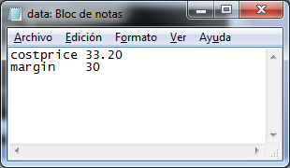 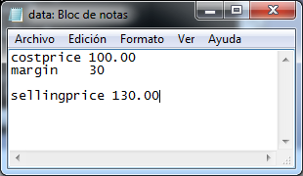

*Exercise 4*. Design and implement a C program using modular programing that displays rectangles as a sequence of N identical symbols. The program must receive the symbol that must be displayed and the value of N from the user. Examples:

 

Symbol: **+** Symbol: **\***

N: 10 N: 5